Discusion-6
Hello class,
In computer science, file structure is usually a tree-like hierarchical organization representation of files stored in secondary memory. “It is also a collection of operations for accessing the data. It enables applications to read, write, and modify data. File structures may also help to find the data that matches certain criteria” (Sari, 2023).
Linux distributions and other UNIX-like operating systems implement Filesystem Hierarchy Standard (FHS) as a file structure system. FHS is a standard that defines the directory structure and directory contents. This standard consists of a set of requirements and guidelines for file and directory placement. “The guidelines are intended to support interoperability of applications, system administration tools, development tools, and scripts as well as greater uniformity of documentation for these systems” (LSB Workgroup, 2015, Abstract section).
In this post, I discuss the importance of understanding file structure, specifically FHS in Linux systems. Understanding FHS is crucial to effectively navigate and managing a Linux system, ensuring cross-distribution compatibility, maintaining system stability, conducting efficient troubleshooting, and implementing appropriate security measures.
Navigating and Managing
The role of a file structure system is to allow software and user to manage files in secondary memory (create, delete, read, write, and modify files). Additionally, FHS is responsible for retrieving the root filesystem, which is used to boot, restore, and/or repair the system (LSB Workgroup, 2015). In the context of Linux, it is crucial to understand the FHS directory structure and directory contents to navigate and manage files. Figure 1 illustrates the Linux directory FHS structure.
Figure 1
Linux Directory FHS Structure
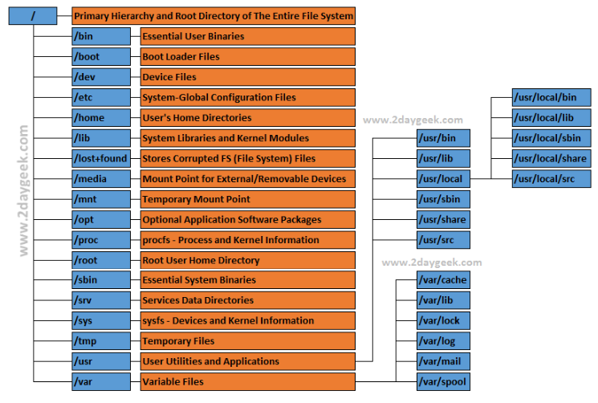

Note. From Linux Directory Structure (File System Hierarchy) Explained with Examples, by M. Maruthamuthu, 2019, (https://www.2daygeek.com/linux-directory-structure-file-system-hierarchy/). Copyrights 2023 2daygeek.com

Cross-Distribution Compatibility
Understanding how FHS differed from other file system structure systems is crucial for applications development and user utilization. FHS’ main quality is that it can support cross-distribution compatibility. In Linux terms, a distribution is an operating system developed by various open-source projects and programmers. “Each distribution includes the Linux kernel (the foundation of the operating system), the GNU shell utilities (the terminal interface and commands)” (“What is a Linux distribution?”, n.d.). In other words, different Linux distributions can have different approaches to file and directory placement and still ensures a level of consistency across distributions. Furthermore, this level of consistency across distributions facilitates the creation of applications compatible across various Linux distributions.
System Stability and Troubleshooting
Maintaining system stability is another key advantage of understanding the FHS. Linux separates user data from system data, static files from dynamic files, and local files from network files. This separation prevents the unintentional alteration or deletion of critical system files, ensuring a stable and secure system.
Effective troubleshooting is an integral part of managing any system. In Linux systems, when problems arise, knowing the FHS will allow you to pinpoint potential sources of issues. For example, if a system service isn't starting as expected, checking files in /var/log might provide useful error messages.
Security
Knowing which directories contain sensitive data or system-critical files helps when setting permissions or installing a security-enhancing software package. FHS allows users to quickly identify important directories, such as /etc for system configuration files, /var for logs and spool files, and /home for user data, amongst others. This makes it easier to configure and enforce security policies across the system.
In conclusion, the file structure is usually a tree-like hierarchical organization representation of files stored in secondary memory, which allows data access and enables applications and users to create, delete, read, write, and modify files. In this post, I discussed Filesystem Hierarchy Standard (FHS) as a file structure system. FHS is a standard that defines the directory structure and directory contents in Linux distributions and other UNIX-like operating systems. Finally, having a good understanding of FHS is essential to effectively navigate and manage files, develop cross-distribution applications, preserve system stability, conduct efficient troubleshooting, and put into place suitable security measures in Linux distributions and other UNIX-like operating systems.
-Alex
References
LSB Workgroup (2015, March 19). Filesystem hierarchy standard [PDF]. The Linux Foundation. Retrieve from: https://refspecs.linuxfoundation.org/FHS_3.0/fhs-3.0.pdf
Sari, S. (2023, May 30). File structures. Baeldung on Computer Science. https://www.baeldung.com/cs/file-structures#:~:text=A%20file%20structure%20is%20a,data%20that%20matches%20certain%20criteria.
Stallings, W. (2018). Operating Systems: Internals and design principles. Pearson
What is a Linux distribution?: Answer from SUSE defines. SUSE Defines. (n.d.). https://www.suse.com/suse-defines/definition/linux-distribution/

